 | Weekly Team Task Report | #3

Team: GeoLearn |  |  |  |  |  | Date: 2/4/2020
Project Title: Improving elementary education with custom online enironmental science lectures

 | Samuel Prassse  Present  On-time | 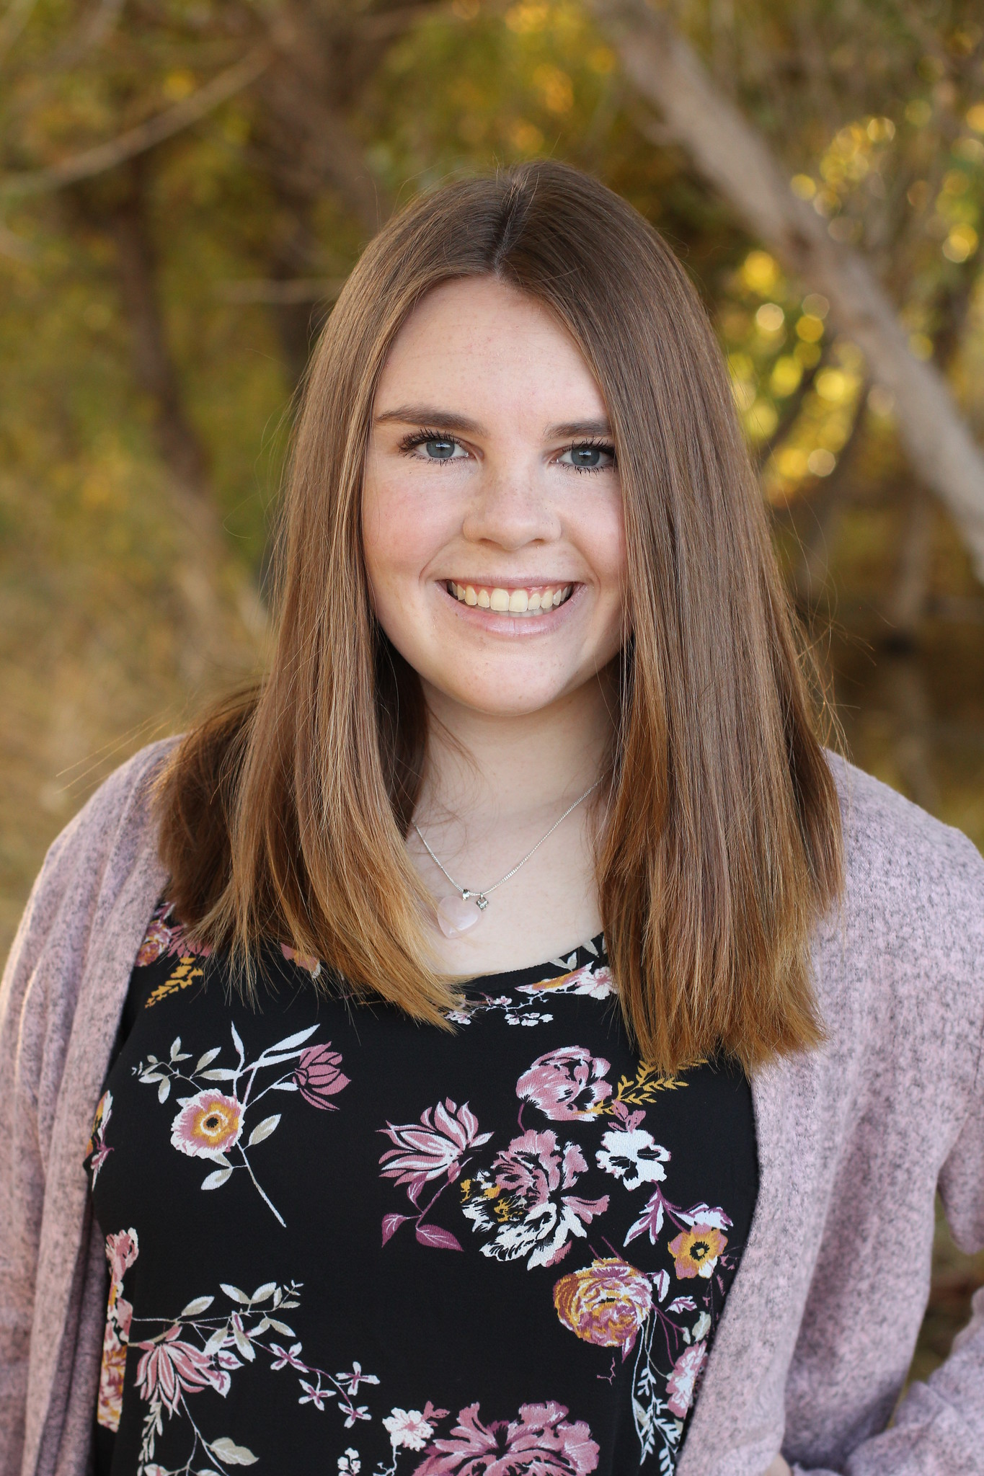 | Kaitlyn Grubb  Present  On-time | 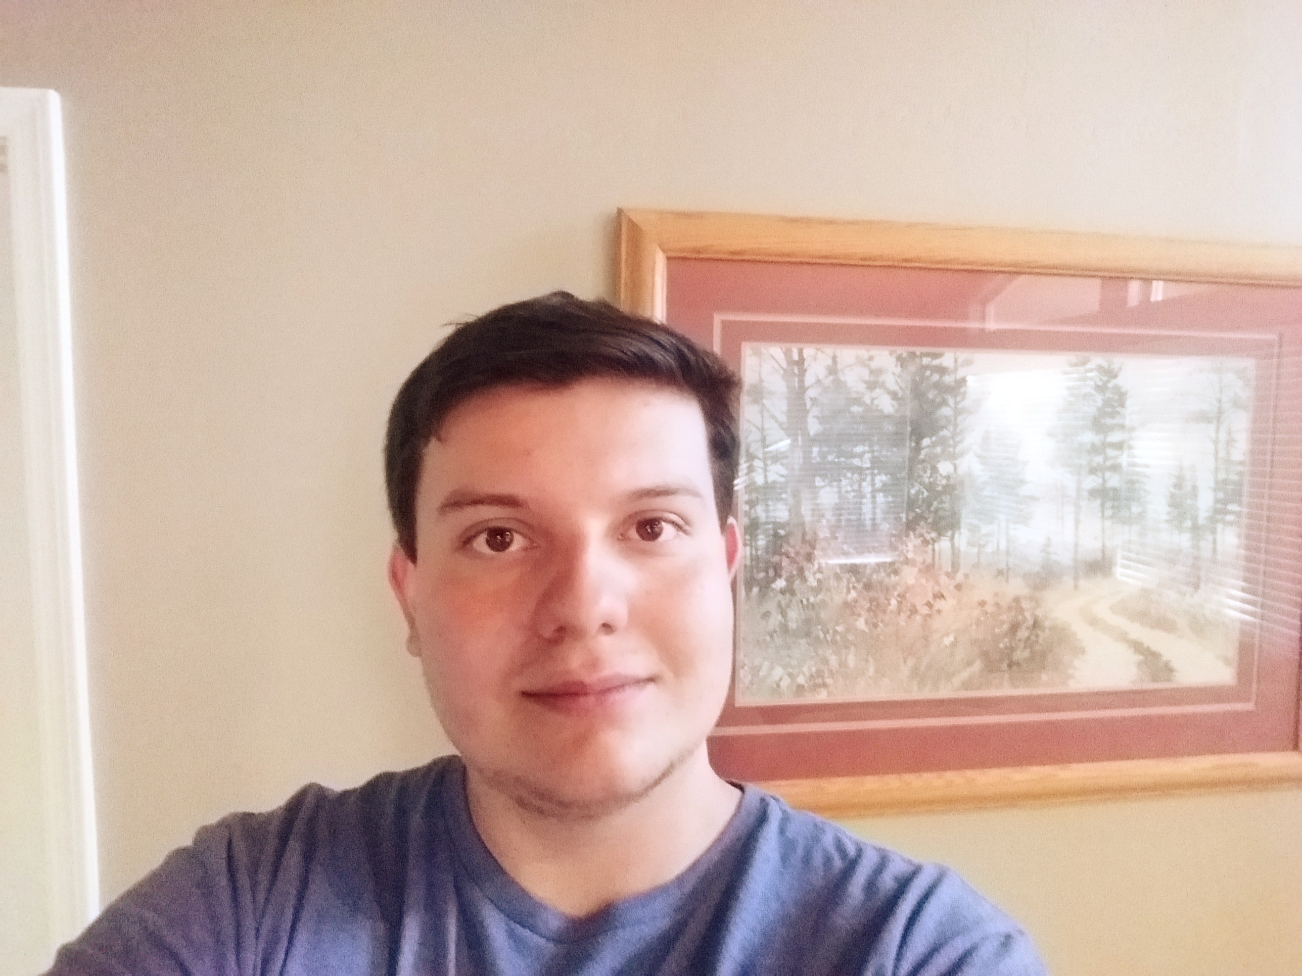 | Tyler Pehringer  Present  On-time |  | 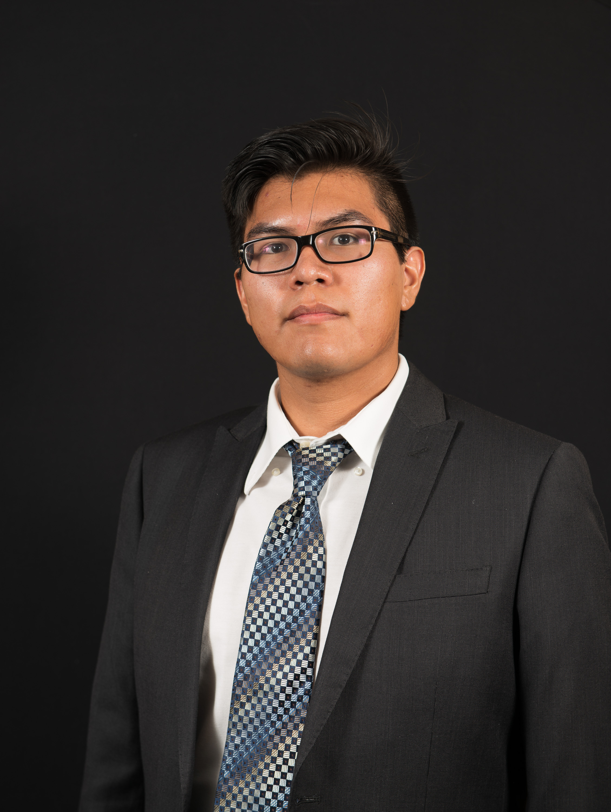 | Joshus Tenakhongva  Present  On-time

Recent Meetings:
- General Team Meeting
- Sponsor Meeting

TASKS COMPLETED since last meeting:

Task Title: Software Design Document Draft | Task Initiation: 1/23 | Orig. Due Date: 2/8 | Status: Completed
Who (%): Team (100%)
Description: This document is a description of our projects overall architechtural design as well as the design of each major module. It is being called, “the blueprint of our final product”. Contains an overview of the architechture of the software and diagrams of each component to give the reader a visualization of how they interact.
Expected Outcome: A very descriptive document that gives the reader an understanding of what, and how our software is working.

This week’s Tasks: Work plan for coming week
Task Title: Slideshow Creation | Task Initiation: 1/30 | Orig. Due Date: 2/6 | Status: In Progress
Who (%): Kaitlyn (50%), Samuel (50%)
Description: Kaitlyn is working on taking the data that Samuel has pulled from Google Earth Engine and placing it into our slideshow presentation. She is also creating an automated version of the slides that Dr. Doughty and team have created for us to implement.
Expected Outcome: Exact replicas of presentations given to us by Dr. Doughty.

Task Title: Website Creation | Task Initiation: 1/23 | Orig. Due Date: 2/6 | Status: In Progress
Who (%): Tyler (100%)
Description: Tyler is working on building the base website in which the team can combine each section of the project. The general website design is still in the works but we intend to have a local server to test our code on and develop the rest of the project.
Expected Outcome: Working website that looks clean and well put together. Site needs to have working parts by next weeks sponsor meeting.

Task Title: Ecolocation Data | Task Initiation: 1/23 | Orig. Due Date: 2/6 | Status: In Progress
Who (%): Joshus (100%)
Description: Joshus is working closely with Roo and Dr. Doughty to develop the Ecolcation aspect of our project. We will be gathering pictures from the web and storing them either locally or in the cloud for every animal in the database. This information will be used for most pictures we use in our slideshow presentations.
Expected Outcome: Working website that looks clean and well put together. Site needs to have working parts by next weeks sponsor meeting.

Upcoming Tasks: Planning
Task Title: Refine Presentation | Who (%): Team (100%) | Rough Due Date: Middle February
Description: The team will meet in the coming weeks to refine different parts of the presentation. We felt there were parts that needed to be developed more such as slide information and meaningful graphics, and the information that was spoken in the presentation

Task Title: Prototype Demo Milestone | Who (%): Team (100%) | Rough Due Date: 3/4
Description: Fully functioning prototype demonstration.

Other Problems / Other Issues:
- N/A

